UNIT 5

# Range, Domain and Codomain

* Do this unit together with Unit 7
* DO ACTIVITIES 5.8, from this unit. Practice the examples on pages 78, 80, 81
* NB do number 2 and 3 of 5.8, you have not done them

Remember this from high school, “I am the Ranger (y) and this is my Domain (x)”



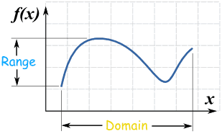

This is my **domain** (x)

I am a **range**r (y)

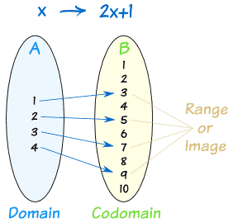

So the **Domain** is the values that go into a function (set A)

The **Codomain**, is what could possibly come out (set B)

The **Range** is the values that actually come out i.e. specific values in set B.

* Range ⊆ Codomain
* Don’t let this confuse you. Just like how we had Cartesian products, the first set in the product had all the values listed first, so these are the **domain**. The values listed second are the **range**.

Example 1 – In this example, S is sort of like the Cartesian product of two sets

Let S = { (a, 1) }, { (b, 1), (a, 2) } be a relation from {a, b, c} to {1, 2, 3}.

Then **dom**(S) = {a, b} ⊆ {a, b, c} and

**ran**(S) = {1, 2} ⊆ {1, 2, 3}.

The **codomain** is the set {1, 2, 3}.

Set B

Set A

# Reflexivity

A relation R on A (also written as R ⊆ A × A) is called *reflexive* on A iff for every

x ∈ A, we have (x, x) ∈ R.

*Loops on each vertex. Mirror image. Literally the only definition you need to remember by heart.*

# Irreflexivity

A relation R ⊆ A × A is called *irreflexive* iff there is *no* x ∈ A such that

(x, x) ∈ R. In other words, for any x ∈ A, (x, x) ∉ R.

*A relation can be neither reflexive nor irreflexive*

*No loops at all*

# Symmetric

A relation R ⊆ A × A is *symmetric* iff R has the property that, for all x, y ∈ A,

if (x, y) ∈ R, then (y, x) ∈ R.

# Antisymmetry

A relation R ⊆ A × A is *antisymmetric* iff R has the property that, for all x, y ∈ A, if x ≠ y and (x, y) ∈ R then (y, x) ∉ R.

*If x=y for all the elements, the relation will be both symmetric and antisymmetric*

# Transivity

A relation R ⊆ A × A is *transitive* iff R has the property that for all x, y, z ∈ A, whenever (x, y) ∈ R and (y, z) ∈ R, then (x, z) ∈ R.

*Don’t think too hard. Literally draw a diagraph or force one (xy) (yz) (xz) relationship.*

# Trichotomy

A relation R on A satisfies the requirement for *trichotomy* iff, for every x and y chosen from A such that x ≠ y, we have that x and y are comparable,

i.e. for all x, y ∈ A such that x ≠ y, x R y or y R x (i.e. (x, y) ∈ R or (y, x) ∈ R).

*Not too hard. Just look for 1 Transivity and antisymmetry.*

*Alternatively, every element should be paired with each other element at least once.*

# Inverse Relation

Given a relation R with domain A and range B, the relation R-1 (read “R inverse”) with domain B and range A is called the *inverse of R* and is defined such that

(x, y) ∈ R if and only if (y, x) ∈ R-1.

# Relation composition

Given relations R from A to B and S from B to C, the composition of R followed by S (S ￮ R or R; S) is the relation from A to C defined by

S ￮ R = R; S = {(a, c) | there is some b ∈ B such that (a, b) ∈ R and (b, c) ∈ S}.

*Not hard. It’s like fusing the first number of a pair in set one with the second number of a pair in set 2.*

*You need to find “matching elements” where the front matches the back*